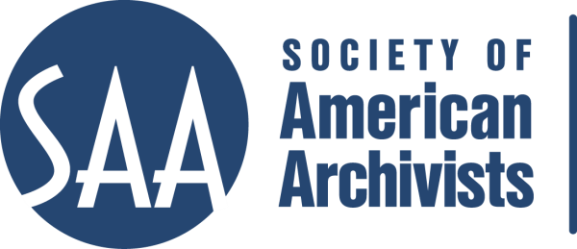
CE Workshop Evaluation Form
Arrangement and Description Track

Workshop Evaluation Form:

Title | Encoded Archival Description
Reviewer: | Naomi Nelson
Directions:
- Quantitative: Each item below begins with a bolded statement. Score each with a 1-5 ranking to indicate your assessment of the veracity of that statement based on your review of workshop overviews/agendas, evaluations, and other materials.
- Qualitative: In the comments section for each item below, please respond to the additional questions posed and any related issues that this workshop raises for you.
- Provide any additional assessments or comments not relevant to one of the specific, numbered areas in the space provided following the table.

Please place an “x” in the appropriate column, use 1=low, undesirable, to 5=high, excellent. |  |  | 1 | 2 | 3 | 4 | 5
1. Does the content appeal to its specified audience? Does it indicate specific categories of archivists and/or levels of expertise to assist potential participants in determining the workshop's relevance for them?  Comments: Would be helpful to be more specific about audience in the course description. |  |  |  |  |  |  | X
2. To what extent does the subject matter reflect current archival practices and theory commonly accepted in the profession?  Comments: Unclear from the course materials whether the introduction includes  - Reviewing why EAD is important—what it enables  - Explaining how EAD relates to other descriptive standards  - Reviewing why XML has been widely embraced as the way to implement EAD. |  |  |  |  |  | X
3.. How relevant/appropriate are the teaching and delivery methodologies (lecture, video, PowerPoint, exercises, film, audiotape, discussion, simulation, case study, opportunities for in-course feedback, etc.) to the articulated goals and objectives, and to the content?"  Comments: |  |  |  |  |  |  | X
4. How workable is the time line or agenda for the course? Is there sufficient detail to indicate how the workshop will evolve? Does it allow sufficient time for active engagement between course participants and the instructor(s)?  Comments: |  |  |  |  |  |  | X
5. To what degree does the list of assigned readings support the content of the proposal?  Comments: The link for the LC best practices is incorrect. Would be nice to include the CDL (or another consortial) EAD best practices site. The EAD RT website no longer appears to have a section called “help pages” and this might confuse folks. Would be helpful to include a link to a “gentle introduction” to XML/SGML. |  |  |  |  |  | X
6. Does the presentation support the Learning Outcomes in the descriptions?  Comments: The learning outcome should be restated to indicate what the student will be able to do after taking the course. |  |  |  |  |  |  | X
 | A&D Track Considerations
 | 1.Does this content bridge, enhance, and/or build on other workshops (If so, please name) | This is an important foundational course. It builds on content learned in Arrangement & Description, DACS, and Beginner’s Guide to Metadata. It bridges to stylesheets, tool workshops (Archon, Archivists Toolkit) and EAD Tips and Tricks.
 | 2.Does this build on other workshops not on the list? | It builds on content learned in Arrangement & Description, DACS, and Beginner’s Guide to Metadata.
 | 3 Should this be part of the A&D Track? | Yes.
 | 4.Where would this workshop fall in the sequence of an A&D track? | The most basic course is A&D of Mss Coll. This course would follow in the next tier.
 | Why? | Since EAD is based on archival A&D practices, it makes sense to learn the theory and practice of basic A&D first. Understanding the concepts in this workshop would be helpful when moving on to courses on particular tools.
 | 5. What tier does this workshop fall in? (See attached tiers) | Foundational
 | 6. Target Audience | Arrangement & Description
 | 7. Is the suggested prior “experience/knowledge” appropriate? | I would suggest that participants will need to understand the principles of archival arrangement and description prior to taking this course. They should know the equivalent of A&D of Manuscript Collections. It would be helpful for participants to know something about HTML
 | 8. Learning Outcomes:  Are they appropriate and/or relevant? | The learning outcome should be restated to indicate what the student will be able to do after taking the course.
 | 9. What should they be?  Please list learning outcomes. | - Explain what Extensible Markup Language is and how it can be used in archival description;  - Explain how EAD is structured;  - Mark up a simple finding aid using EAD;  - Use a basic style sheet to transform the EAD finding aid into a format that can be presented on the web;  - Suggest and evaluate implementation strategies;
 | 11. Would parts of the content lend themselves to a different format? | No.
 | 12. Which parts?
 | 13. Does it lend itself to repurposing as an audio CD? | No. Hands on experience is important to this course.
 | Which parts?

Other comments:

This is a core competency for the profession, and the instructors have both proved themselves to be very effective teachers.

